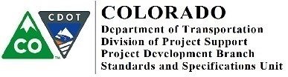
MEMORANDUM
DATE: May 1, 2019

TO: All Holders of Standard Special Provisions

FROM: Shawn Yu, Standards and Specifications Unit Manager

SUBJECT: Revision of Section 105 – Cooperation by Contractor

Effective this date, our unit is issuing a new standard special provision, Revision of Section 105 – Cooperation by Contractor. This new standard special provision is one page long.

Please use the Revision of Section 105 - Cooperation by Contractor standard special provision on all projects, beginning with projects advertised on or after June 1, 2019. You are free to use this standard special provision in projects advertised before this date.

For those of you who keep a book of Standard Special Provisions, please add this new specification. For your convenience, you can find this in one place on our Construction Specifications web page: https://www.codot.gov/business/designsupport/cdot-construction-specifications/2017-construction-standard-specs/rev-ssp/rev-sec100-ssp/rev-sec-105cbc/view

You may also visit the hyperlink, “Recently Issued Special Provisions”.

If you have any questions or comments, please contact this office.
2829 W. Howard Pl., 3rd floor, Denver, CO 80204 P 303.757.9474 F 303.757.9820 www.codot.gov |

